**Data Exchange between two Android Devices using QR Code**

**PROJECT MEMBERS**

Jophin Joseph N, 1MV15CS042

M D Pavan Kumar, 1MV15CS053

Dept of CSE, Sir M. Visvesvarya Institute of Technology, Bengaluru

**PROJECT MENTORS**

Mr. Raja Ramesh

Mr. Dorababu

**ACKNOWLEDGEMENT**

We give our high, respectful gratitude to our Mentor **Mr. Raja Ramesh** and **Mr. Dorababu** who has been our source of inspiration. He has been especially enthusiastic in giving his opinions and critical reviews. We have learnt a lot throughout this internship with many challenges yet valuable experience to complete this task. We will remember his contribution forever.

We sincerely thank **Mr. BadiyuZama Mohammed and Mr. Harish Daga**, who have been the constant driving force behind the completion of project. We also thank **Mr. Prasad Kothapalli** for his constant help and support throughout.

Our thanks and appreciations also go to our friends who have willingly helped us with their abilities.

- Jophin Joseph N

- M D Pavan Kumar

**TABLE OF Contents**

**Chpt No. TITLE PAGE**

**1 INTRODUCTION 1**

**2 MOBILE QR CODES 2**

**3 DESIGN OF QR CODES 4**

3.1 Encoding 4

**4 IMPLEMENTATION OF QR CODES 5**

4.1 Generators 5

4.2 How to scan QR codes 7

**5 SECURITY OF QR CODES 8**

5.1Public and Private keys 8

5.2S\_QR algorithm 9

5.3EK\_EQR algorithm 15

**6 DATA COMPRESSION 17**

**7 VERSIONS OF QR CODE 18**

**8 ARCHITECTURAL DIAGRAM 19**

**9 QR CODE IN HOSPITALS 19**

9.1 Patient identification 20

9.2 Outpatient identification 21

9.3 Authorization 21

9.4 System design 22

9.5 Information access 23

9.6 Emergency responder’s authentication 24

**10 CONCLUSION AND FUTURE**

**ENHANCEMENTS 24**

**11 REFERENCES 25**

**Data Exchange between two Android Devices using QR Code**

***Abstract-***.There are various types of information which being transferred from the known source to required destination. The data that is being transferred can be confidential which should be handled with much care. The transferring of data can be done using various technique and numerous types of algorithms. QR code is one of the technique which can be used to transfer the data with maximum amount of security being involved. In this paper we present a new technique of data encryption method using QR code.We designed a QR Code generating system to integrate into the healthcare system. This system provides QR code-based medical identification alerts and an in-hospital patient identification system.Smartphone or standalone QR code scanner can be used to scan the code. The design of this system allows authorized personnel (e.g., paramedics, firefighters, or police) to access more detailed patient information than the average smart phone user: emergency service professionals are authorized to access patient medical histories to improve the accuracy of medical treatment.

**1. Introduction**

A QR code or Quick Response barcode is a two-dimensional barcode first introduced in 1994 by Nippondenso company of Japan. At first these barcodes were used primarily in the manufacturing and automotive industry. QR codes are essential in tracking information or marketing. Since these QR codes are now found everywhere, the mobile user must install a QR code Reader app first if planning to scan a two-dimensional code. Then the mobile user can obtain contact information, a URL, sms text, or a phone number all from scanning with the mobile device and it instantly can translate the QR Code.

Smartphone users can take a picture of the QR code with their phones, which then sends their mobile directly to the hospital for a medical appointment. In order to read QR codes, users need to download a QR scanner application,because smartphones are widely used across various life domains, reading and decoding QR codes has become much easier than using systems based on complex technology.

QR code-based technology is also superior in other ways, such as higher data storage capacity, lower implementation cost, technical simplicity, widespread use, and widely available, free programs for reading and decoding by camera-equipped smartphones. These features make this technology attractive for patient identification purposes.Therefore, the system has to be cost-efficient and easily implemented. These requirements make QR code technology the best choice for our system, which will be used for both QR code-based medical identification alerts and patient identification in hospitals. More and more people are creating their own custom QR codes to share information, or for small businesses to track their product or services.

How to make a QR Code:

• First you have to create a QR barcode generator.

• Then select the type of information or data you want to be embedded in your QR code.

• Then enter all the data into the QR code generator and submit.

• Save the generated QR barcode onto your computer.

• Open the QR code image and scan using QR reader.

From having the generated code you can track when the barcode is scanned.This way you know how to make a QR code now and can obtain or send essential information for entertainment purposes or marketing campaigns.

**2. Mobile QR codes**

Constantly the technology for mobile phones is expanding, especially in the mobile internet, mobile QR codes are the perfect solution to efficiency and quickness for users in the mobile web. QR code readers are built in to most of todays smart phones. The QR codes can be used to store all sorts of data. URL’s are universal resource locaters in which people can access web addresses. These QR codes make viewing offline publications fun and easy.

The smartphone QR code reader works by accessing the users built in camera and captures an image of QR codes. Decoding software is required to transform the image into a meaningful action for the mobile phone.All this can be done in milliseconds connecting user mobile phones to other mobiles instantaneously. There is multiple ways of scanning a barcode on your mobile device, you can capture and decode QR codes from your computer screens or online via direct URL, or even in an image download. You can generate these mobile phone-readable two dimensional barcodes containing an impressive amount of storage for use of the personal users.

[An external file that holds a picture, illustration, etc.
Object name is 40064_2016_3020_Fig1_HTML.jpg](https://www.ncbi.nlm.nih.gov/pmc/articles/PMC5005258/figure/Fig1/)

Cell phone QR code readers have many different types of scanners and decoders. The optiscan is the best scanner for iphones it encodes all the newer trickier QR codes and has always stayed current on the developing technology. The I-Nigma is the most popular decoder/reader application on todays smartphones. Quickmark is used mostly in the android market as well as on windows mobile versions. The blackberry messenger comes standard in blackberrys and makes decoding barcodes very user friendly. Applications like snapmaze make it possible to read QR codes for Nokia, Sony Ericcson and Motorola phones. Jaxo systems and Okotag run on java-enabled phones and have the newest of technology and supportive devices.

**3. Design of QR codes**

Unlike the older, one-dimensional barcodes that were designed to be mechanically scanned by a narrow beam of light, a QR code is detected by a camera lens and then digitally analyzed by a programmed processor. The processor locates the three distinctive squares at the corners of the QR code image, using a smaller square (or multiple squares) near the fourth corner to normalize the image for size, orientation, and angle of viewing. The small dots throughout the QR code are then converted to binary numbers and validated with an error-correcting algorithm.

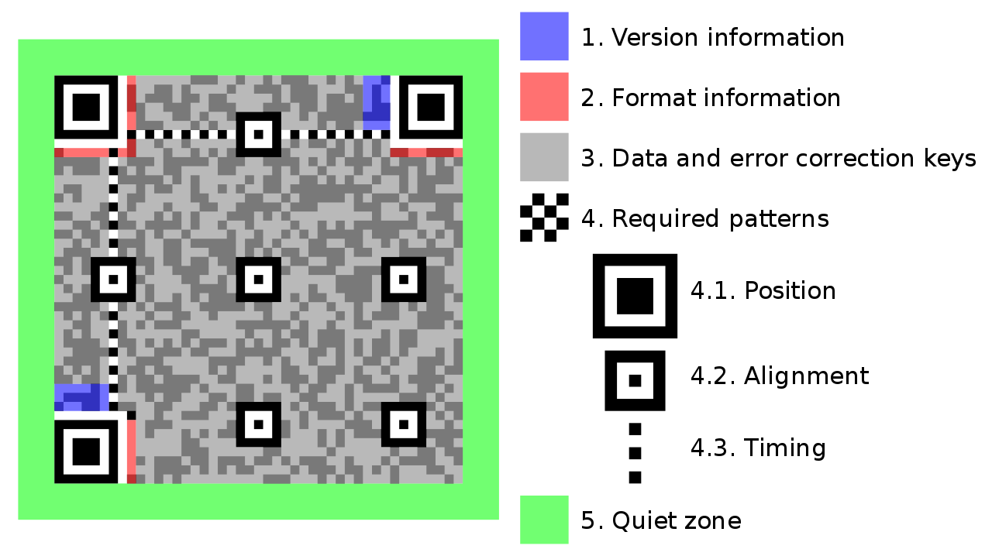

**3.1 Encoding**

The format information records two things: the error correction level and the mask pattern used for the symbol. Masking is used to break up patterns in the data area that might confuse a scanner, such as large blank areas or misleading features that look like the locator marks. The mask patterns are defined on a grid that is repeated as necessary to cover the whole symbol. Modules corresponding to the dark areas of the mask are inverted. In larger symbols, this is complicated by the presence of the alignment patterns and the use of multiple interleaved error-correction blocks.

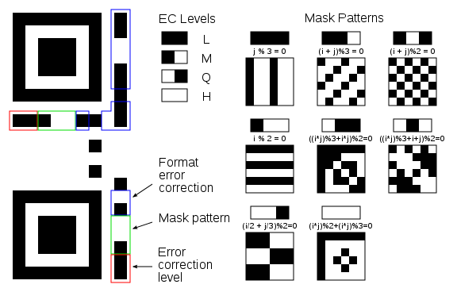

**4. Implementation of QR codes**

**4.1 Generators**

QR codes are easy to set up and they offer a huge range of multiple uses for marketers. QR means Quick Response; these scan able QR barcodes can be read quickly by mobile devices. QR codes take information from transitory media and put it on to your mobile device. In order to scan QR codes you must first have a QR code Reader application in your android device.

To make your own QR code is as simple as connecting your URL to the two-dimensional barcode.The amount of stored data in the QR code depends directly on the character set, the version and also the error correction level.

Custom QR codes are the biggest thing in marketing and not just for big brands but also for the consumer. For your business to make your own QR code is essential, it bridges online information accessed from the offline world. These monochromatic barcodes can be automatically created by QR code generators and cannot be modified without affecting the scan ability. To make your own QR code you have to first figure out what type of information you want to share then find a compatible QR code generator. Using a zxing library we can convert any data into QR image. . ZXing (pronounced "zebra crossing") is an open-source, multi-format 1D/2D barcode image processing library implemented in Java, with ports to other languages. Its focus is on using the built-in camera on mobile phones to scan and decode barcodes on the device, without communicating with a server, though the library also supports use on a server.At heart it is a pure Java library for decoding barcodes. It also contains several applications for Android, Google Glass, a JavaEE web application, and a GWT-based encoder application. Some of Its features are:

1. Can be used via Intents (little code required).
2. Can be embedded in an Activity, for advanced customization of UI and logic.
3. Scanning can be performed in landscape or portrait mode.
4. Camera is managed in a background thread, for fast startup time.

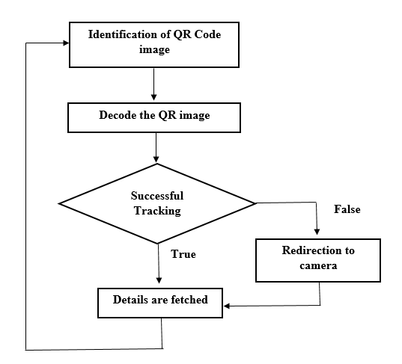

Most of todays applications target mobile users using mobile tagging. You can print, or compose an email or text after scanning the code. There are scanning, reader application, and generators for most of todays smart phones and also online

**4.2 How to Scan QR Codes**

Quick Response (QR) codes are becoming increasingly popular within the United States. Reports show that as of June 2011, 14 million people used their mobile phones to scan a QR code in America. This figure is only 6.2 percent of the total amount of people who own a mobile device, so the number is expected to continue rising. Although the exact method you use to scan these codes with your mobile phone differs depending on the type of phone you have, the general concept is the same and can be modified for your specific model.

Locate and download the appropriate application for your phone. The source you will obtain this app from depends on the type of phone you have, and will activate the camera on your phone in order for it to capture the barcode information. For instance, if you have an iPhone, the scanner application will be downloaded from the App Store. Other the other hand, if you have an Android phone, look through the Android Market; for Blackberry users, you will find the app you need in App World.

Launch the application you have downloaded whenever you are ready to scan a QR code. Place this app in your frequently used or favorites section within your smart phone for easy access whenever you wish to quickly access information.Select the option to scan the barcode once your application is open. In order for the phone to be able to read the code, you will need to hold it still while the camera is focusing. Once the application has successfully read the code, you will be taken to the appropriate page of information. If the code you scanned is designed to make a phone call or send an SMS message, you will be taken to this action.If it fails to scan then a prompt message is displayed and control goes to phone camera to rescan the QR image.

**5. Security of QR codes**

**5.1 Public and Private keys**

The Public and Private key pair comprise of two uniquely related cryptographic keys (basically long random numbers).

The Public Key is what its name suggests - Public. It is made available to everyone via a publicly accessible repository or directory. On the other hand, the Private Key must remain confidential to its respective owner.

***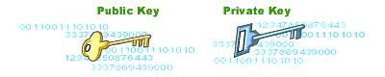***

Because the key pair is mathematically related, whatever is encrypted with a Public Key may only be decrypted by its corresponding Private Key and vice versa.

For example, if Bob wants to send sensitive data to Alice, and wants to be sure that only Alice may be able to read it, he will encrypt the data with Alice's Public Key. Only Alice has access to her corresponding Private Key and as a result is the only person with the capability of decrypting the encrypted data back into its original form.

***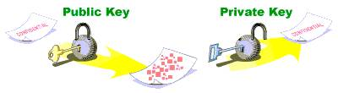***

As only Alice has access to her Private Key, it is possible that only Alice can decrypt the encrypted data. Even if someone else gains access to the encrypted data, it will remain confidential as they should not have access to Alice's Private Key.

**5.2 S\_QR (Secured QR) Algorithm**

With the current implementation, each character of an embedded digital signature is stored in the corrupted message bit string as noted in Algorithm 1. Each of these characters is represented by a byte in the bit string. The first 7 bits of this byte represent the character in the embedded message, translating to an ASCII value between 0 and 127. The 8th bit in the byte is always flipped to guarantee a detectable difference within each corrupted byte of an embedded message.

A digital signature scheme typically consists of three algorithms:

1. A key generation algorithm that selects a private key uniformly at random. The algorithm outputs the private key and a corresponding public key.

2. A signing algorithm that, given a message and a private key, produces a signature.

3. A signature verifying algorithm that, given a message, public key and a signature, either accepts or rejects the message's claim to authenticity.

In S\_QR method we have used the following procedure:

(i) Encrypt the small file containing the information using RSA algorithm and generate corresponding digital signature & public key.

(ii) For size compression and unification, compress the original file along with the corresponding digital signature and public key into a zip file

(iii) Generate QR Code for the newly created zip file

. 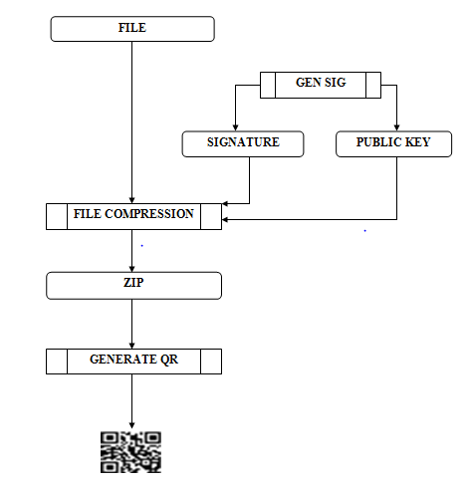

**Encoding process**

To decode the information using Android device, the authors used the following procedure:

(i) Scan the QR Code using the camera of the device and write the decoded data into a new zip file.

(ii) Decompress the zip file and display the contents of the main file.

(iii) If requested by the user, verify the authenticity of the main file using corresponding digital

signature and the public key and display the verification result.

**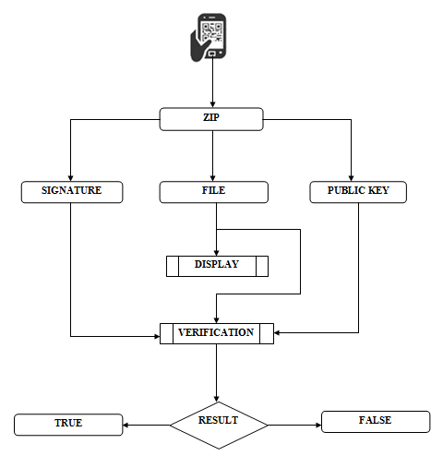**

**Decoding process**

**Digital Signature Generation Algorithm: (GenSig)**

STEP 1: Start

STEP 2: Create a Key Pair[2]

STEP 3: Initialize the Key Pair randomly

STEP 4: Generate the Private Key and Public Key

STEP 5: Get a Signature Object[2]

STEP 6: Initialize the Signature Object with Private key

STEP 7: While read buffer data from input file ≠ 0

Update the data to be signed by each byte read.

STEP 8: Generate the RSA Digital Signature

STEP 9: Write the Digital Signature into 'sig' file

STEP 10: Encode the public key and write it into 'suepk' file

STEP 11: End

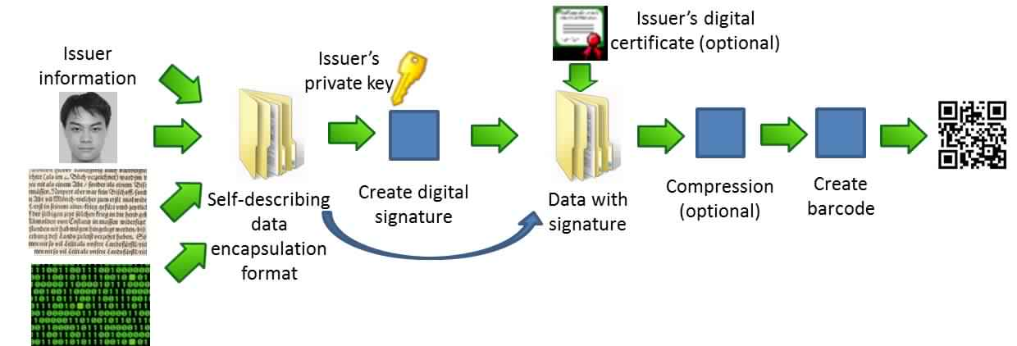

Workflow for the generation of an authenticated 2D barcode for an input data

**Digital Signature Verification Algorithm: (VerSig)**

STEP 1: Start

STEP 2: Input the encoded RSA public key(suepk), signature(sig) and the source file(infile)

STEP 3: Obtain Key Specification

STEP 4: Convert the encoded RSA public key bytes and obtain the key

STEP 5: Input the Digital Signature bytes

STEP 6: Initialize the Signature Object for verification

STEP 7: While read buffer data from infile ≠ 0

Update the data to be verified by each byte read.

STEP 8: Match with the Digital Signature to verify

STEP 9: If matching is correct then

Display 'Verification: True'

else

Display 'Verification: False'

STEP 10: End

**QRCode Generation Algorithms: (GenQR)**

STEP 1: Start

STEP 2: Input the source file(infile)

STEP 3: Call GenSig(infile)

STEP 4: Compress 'suepk','sig' and 'infile' into 'test.zip' file

STEP 5: Create an empty string data

STEP 6: Convert 'test.zip' into string and store in 'data'

STEP 7: Input the image format and resolution of the QR Code to be generated

STEP 8: Input Error Correction Level

STEP 9: Using zxing[1] library method convert 'data' into a BitMatrix object 'bitmatrix'

STEP 10: Write bitmatrix to an image

STEP 11: End

Note **-** BitMatrix represents a 2D matrix of bits.

**QR Code Decoding Algorithm: (Decode\_QR)**

STEP 1: Start

STEP 2: Input QR Code image

STEP 3: Construct a Binary Bitmap object 'bitmap' from source image

STEP 4: Using zxing library method decode the 'bitmap' and store it in the object 'result'

STEP 5: Convert 'result' into string and write it to 'result.zip'.

STEP 6: Extract result.zip

STEP 7: If requested by user call VerSig('supek','sig',infile)

STEP 6: End

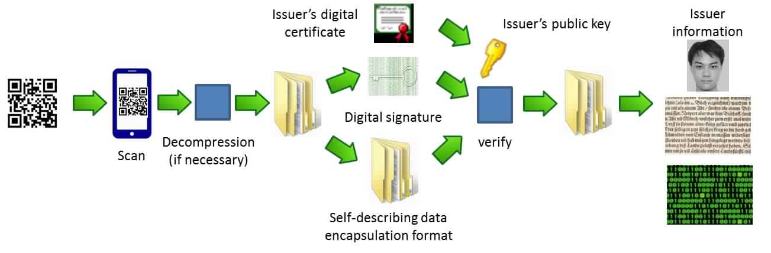

Workflow for the scanning/ decoding of an authenticated 2D barcode.

**5.3. Encrypted key – Encrypted QR algorithm (EK\_EQR)**

**5.3.1 Encryption**

Encryption changes data or information which is in the form of plaintext through the usage of an algorithm so that someone must possess certain knowledge to access it[1]. This special knowledge is normally called a key. Encrypted QR codes are the codes that cannot be scanned and accessed by every individual. They are not very common, since most QR codes are used in marketing, and the developers of those codes want them to be accessible by everyone. We are using EQR algorithm for hiding data before encoding in QR code. In this algorithm we are using symmetric key method means same key will be used for encryption and decryption both.

Encryption in EK-EQR algorithm has two steps

1. Encrypt DATE factor.

2. Encrypt User ID with key-encrypted DATE factor

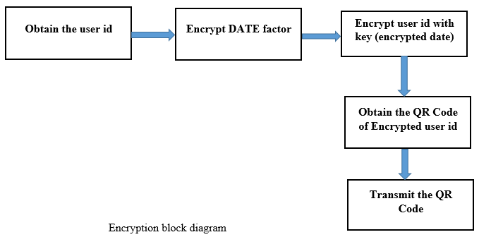

**5.3.2 Decryption**

To decrypt data, we have two steps.

1. Encrypt DATE factor

2. Decrypt cipher text using key

**1. Encrypt Date Factor**

We have already seen encryption of DATE factor. We have to follow same procedure. As we are using symmetric key, we need same key for decryption of cipher data. So to create same key we encrypt DATE factor again.

**2. Decrypt Cipher Text using Key**

In decryption procedure, we use reverse engineering mechanism so we will get original data. Decryption can be done only using same key which was used at time of encryption. When QR code scanner scans QR to generate encrypted data and then it will process for decryption. Reverse engineering of all steps will leads to original data.

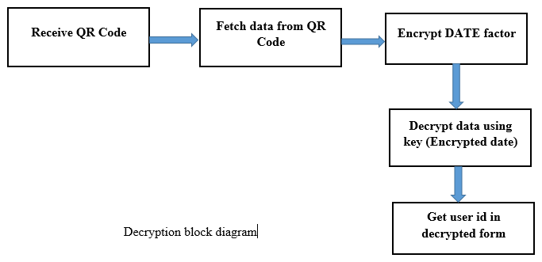

**6. Data Compression**

In computer science and information theory, data compression, source coding,[1] or bit-rate reduction involves encoding information using fewer bits than the original representation. Compression can be either lossy or lossless. Lossless compression reduces bits by identifying and eliminating statistical redundancy. No information is lost in lossless compression. Lossy compression reduces bits by identifying marginally important information and removing it.

Compression is useful because it helps reduce the consumption of resources such as data space or transmission capacity.

**6.1 Compression Technique**

The compression technique followed here allows the user to compress the data so that a large quantity of data can be stored in a small sized bar code. More than 4 kb of data can be stored in this small barcode . The compression which is employed here actually uses two steps: converting the text data into binary form and then generating the hash map data from this binary data. As in fig 2 below

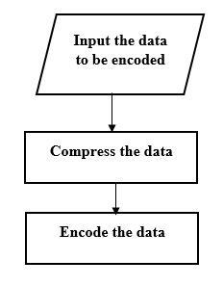

**7. Versions of QR code**

The symbol versions of QR code range from version 1 to version 40. Each version has a different module configuration or number of modules.(The module refers to the black and white dots that make up QR code).Module configuration refers to the number of modules contained in a symbol, commencing with version 1(21x21 modules) to version 40(177x177 modules).Each higher version number comprises 4 additional modules per side.

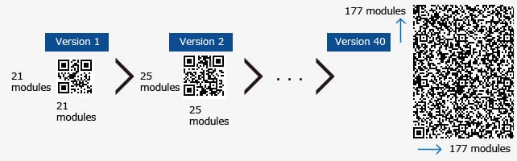

Each QR code symbol version has the maximum data capacity according to the amount of data, character type and error correction level. In other words, as the amount of data increases, more modules are required to compromise QR code, resulting in larger QR code symbols.

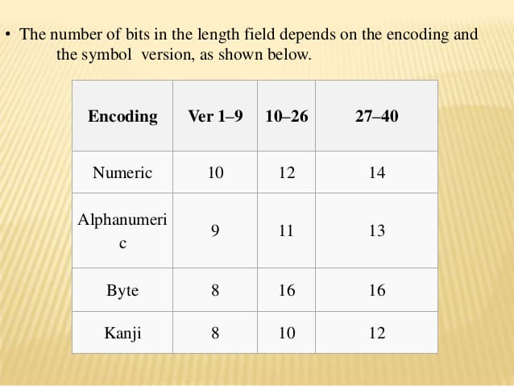

**8. Architectural Diagram**

**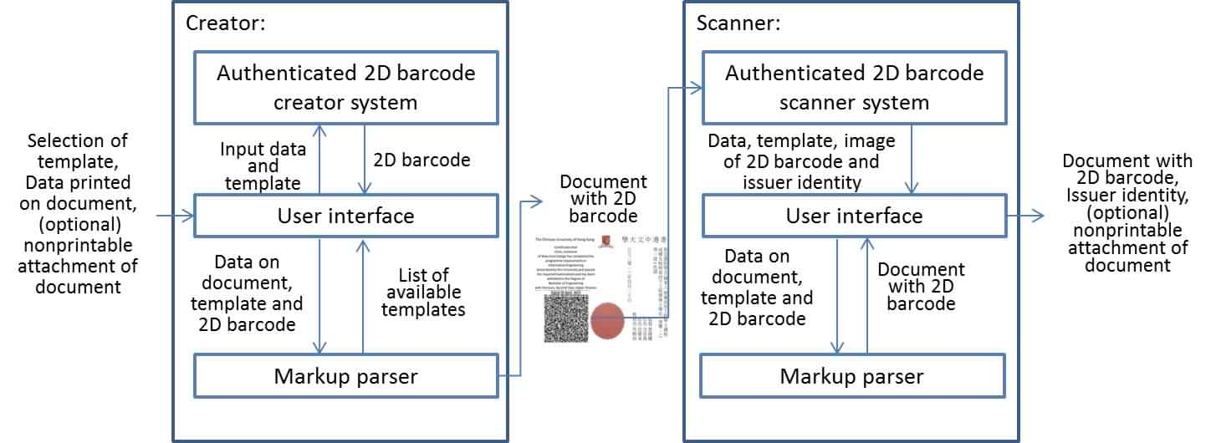**

**9. QR codes in hospitals**

Hospitals have not necessarily embraced services like social media but are starting to ding that QR codes can help in a number of ways, from tracking patient medication to creating mobile websites. QR codes have been around since the early 1990s but are just beginning to go mainstream in the United States. QR codes seem to be attractive to marketers because of their low cost and ease of use.

QR codes can help hospitals make one of their biggest marketing challenges more simple; to integrate social media into their marketing efforts. Hospitals can use QR codes in some of the following ways

* Use a QR code to link to a find-a-doctor tool in the hospitals direct mail pieces.
* Use a QR code in an article to link to a YouTube video of a doctor explaining how an interesting new procedure works.
* Place a QR code on a billboard that links to the hospital’s website so users can scan it to obtain more information.
* Some hospitals are integrating the use of QR codes into the ER wait
* Place a QR code on a hospital website that links to a map or directions to the hospital.
* Set up QR codes so that patients can make appointments easily by being connected to a phone number.
* Find out information about the hospital such as visiting hours, doctors on call, and more.
* Locate hotels, shops, and restaurants that are in close proximity to the hospital.

It is important for hospitals to carefully plan out their use of QR codes. Ideally, a QR code should point to a mobile friendly application that will allow users to obtain information in a fast manner. The basic idea behind QR codes is to make sure the people can easily obtain the information they need when they need it. Hospitals can use QR codes to help overcome marketing challenges and get the word out about their services.

**9.1 Patient identification in hospital environment**

When the QR code is scanned by medical personnel, EMTs, police, or firefighters using the QR based application on their smartphones, detailed patient information is displayed. We prefer to employ QR code-based identification, because QR code-based tag technology, when read and decoded by smartphones, is considered the most useful and cost-efficient alternative for automatized patient identification. Further, it provides quick remote access to health records by medical professionals in public healthcare systems with limited budgets.

To receive treatment, each patient first needs to register with the hospital system.. Incoming patients are also required to provide a detailed medical history. In most hospitals, patients complete a paper copy of the form; however, in our system, patients are encouraged to use on online form, which can be accessed by scanning the QR code of the patient. The form includes an emergency contact patient first name, last name, date of birth, blood group, emergency contact number, address, telephone number, blood type, contact information of a person with the same blood type, allergies, illnesses, special conditions, current medications, and other information.

Several copies of the QR code are produced for each patient admitted into the hospital, and they are used wherever patient identification is required. Copies of the QR code are placed on the door of the patient’s room, the bed, and the chart so that medical personnel can quickly identify the patient and obtain his/her medical history and treatment status. The QR codes are scanned by doctors before surgeries to identify the patient and avoid surgical errors. QR codes are also placed on the patient’s lab samples to prevent errors and maintain information privacy.

**9.2 Outpatient identification**

Some patients may always wear the QR code identity bracelet/necklace/identification card(mobile devices instead), which could be useful for patients with, e.g., allergies, asthma, unusual blood types, HIV/AIDS, diabetes, and Alzheimer’s.

Initially, interested parties need to register themselves or those under their care with the QR Code based system.The member is prompted to enter detailed information, including an emergency contact phone number, addresses, telephone numbers, blood type, contact information of a person with the same blood type, allergies, illnesses, special conditions, and current medications.

When the process is completed, a QR Code is generated for the user, and the user is advised to share the QR code with the listed emergency contact person. The QR Code can be printed, or the member can order a bracelet, necklace, or keychain encoded with it. Users can change their information anytime by logging in into the patient page.

**9.3 Authorization**

Medical personnel, EMTs, police, or firefighters may install the QR Code mobile application and log into the system to gain easy access to the information. They are assigned privileges to obtain the information without contacting the next of kin for rapid access during an emergency.When an authorized individual listed above scans the QR Code,they obtain detailed information about the person to whom the QR image belongs directly. When someone without authority scans the QR image, contact information of the emergency contact is displayed. In a hospital environment, both the patient’s personal details and medical records are available to medical personnel.

**9.4 System Design**

Our system consists of three parts: website, database, and mobile application.The website is used to maintain the PHRs stored in the database, while the mobile application provides easy access to them.

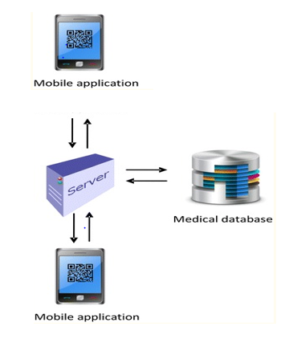

**9.5 Information access flow**

**Find QR Code**

**Scan QR Code**

**Decode QR Code**

**Authorized personnel?**

**No**

**Display error message**

**Yes**

**Medical personnel?**

**Yes No**

**Display patient details**

**Do not display patient details**

**Display medical records**

Emergency contact information can be obtained by scanning the code with any standard QR Code reader,but additional information is retrieved and revealed when the code is read with QR Code reader mobile application.This helps emergency medical responders to provide more informed medical care.The above fig shows how a QR Code is scanned and how basic or detailed information is accessed.

**9.6 Emergency responder’s authentication**

A proper authentication paradigm assures that the correct individuals have access to medical records occurs in the correct contexts. Authorized personnel include police, firefighters, EMTs and hospital medical personnel, to whom the application will be distributed freely by the healthcare system.When medical personnel scan the QR code using the mobile application in a hospital environment, in addition to detailed patient information, they can access the patient’s medical records. However, when other authorized personnel scan the code, they can only access the detailed information about the patient.

**10. Conclusion and future enhancements**

**10.1** QR is an emerging strategy. In spite of the past year’s rapid adoption curve, using QR codes in healthcare marketing and advertising is still “emerging.” It’s open territory for inventive new uses, but detailed historic data is hard to find.

**10.2** It’s immediate and direct. Marketing people love the direct-to-one nature of the tool. People scanning a QR code are proactively requesting information. It indicates a degree of interest and is a further opportunity to convince, but there’s no assurance they will “buy.”

**10.3** Check the demographic fit. Know your audience because the track record isn’t too deep with QR. Look for opportunities where your message is going to be a good match with the user audience (with smartphones). One recent source is ScanLife Mobile Barcode Trend Report (December 2010).

**10.4** Be prepared to handle immediate response. There’s no guarantee about response rates, but if you use a QR code, the implied promise is, well…a “quick response.” Don’t offer a special report that’s not finished, or link to a phone connection that no one answers.

**10.5** Extra bells and whistles may have a fee. Online services and apps create and read codes, usually for free. But additional services such as tracking and analytic dashboards are often in the premium version.

**10.6** Make it trackable. And track response. You may want the “premium” features in order to adequately track performance. Creating the QR code is the easy part. Having a data dashboard, analytics/metrics system or other productivity tools provide insight about the effectiveness.

Github Repository **-** <https://github.com/JophinandPavan/QRCodeApp>

**11. References**

[1] Ada S, Bal CG, Celik A, Akgemci T. Discretionary use of family practice information systems: an empirical examination in Turkey. Health InfManag J. 2013;42(2):17. [PubMed]

[2] Al-Khalifa HS. Utilizing QR code and mobile phones for blinds and visually impaired people. Berlin: Springer; 2008. pp. 1065–1069.

[3] Avidan A, Weissman C, Levin PD. Integration of QR codes into an anesthesia information management system for resident case log management. Int J Med Inform. 2015;84(4):271–276. doi: 10.1016/j.ijmedinf.2014.12.007. [PubMed] [Cross Ref]

[4] Bangor A, Kortum PT, Miller JT. An empirical evaluation of the system usability scale. Int J Hum Comput Interact. 2008;24(6):574–594. doi: 10.1080/10447310802205776. [Cross Ref]

[4] Bangor A, Kortum P, Miller J. Determining what individual SUS scores mean: adding an adjective rating scale. J Usability Stud. 2009;4(3):114–123.

[5] Bates DW, Larizgoitia I, Prasopa-Plaizier N, Jha AK. Global priorities for patient safety research. BMJ. 2009;338:b1775. doi: 10.1136/bmj.b1775. [PubMed] [Cross Ref]

[6] Bellot J, Shaffer K, Wang M. Use of quick response coding to create interactive patient and provider resources. J Nurs Educ. 2015;54(4):224–227. doi: 10.3928/01484834-20150318-07. [PubMed] [Cross Ref]

[6] Bennett LS (2012) U.S. Patent Application No. 13/464,938

[7] Booth P, Frisch PH, Miodownik S (2006) Application of RFID in an integrated healthcare environment. In: Engineering in medicine and biology society, 2006. EMBS’06. 28th annual international conference of the IEEE [PubMed]

[8] Brooke J. SUS: a retrospective. J Usability Stud. 2013;8(2):29–40.

[9] Brooke J, et al. SUS—a quick and dirty usability scale. Usability Eval Ind. 1996;189(194):4-7

[10] Camgöz-Akdag H, Zineldin M. Quality of health care and patient satisfaction: an exploratory investigation of the 5Qs model at Turkey. ClinGovInt J. 2010;15(2):92–101. doi: 10.1108/14777271011035031. [PubMed] [Cross Ref]

[11] Çelebioğlu F (2015) Regional disparity and clusters in Turkey: a Lisa (Local Indicators of Spatial Association) analysis. DumlupınarÜniversitesiSosyalBilimlerDergisi 28

[12] Celebioglu F, Dall’erba S. Spatial disparities across the regions of Turkey: an exploratory spatial data analysis. Ann Reg Sci. 2010;45(2):379–400. doi: 10.1007/s00168-009-0313-8.

[13] Charoensiriwath C, Surasvadi N, Pongnumkul S, Pholprasit T (2015) Applying QR code and mobile application to improve service process in Thai hospital. In: IEEE 12th international joint conference on computer science and software engineering (JCSSE), 2015, pp 114–119

[14] Denso ADC (2011) QR code essentials. Denso Wave. https://www.nacs.org/LinkClick.aspx?fileticket=D1FpVAvvJuo%3D&tabid=1426&mid=4802. Accessed 18 Aug 2016